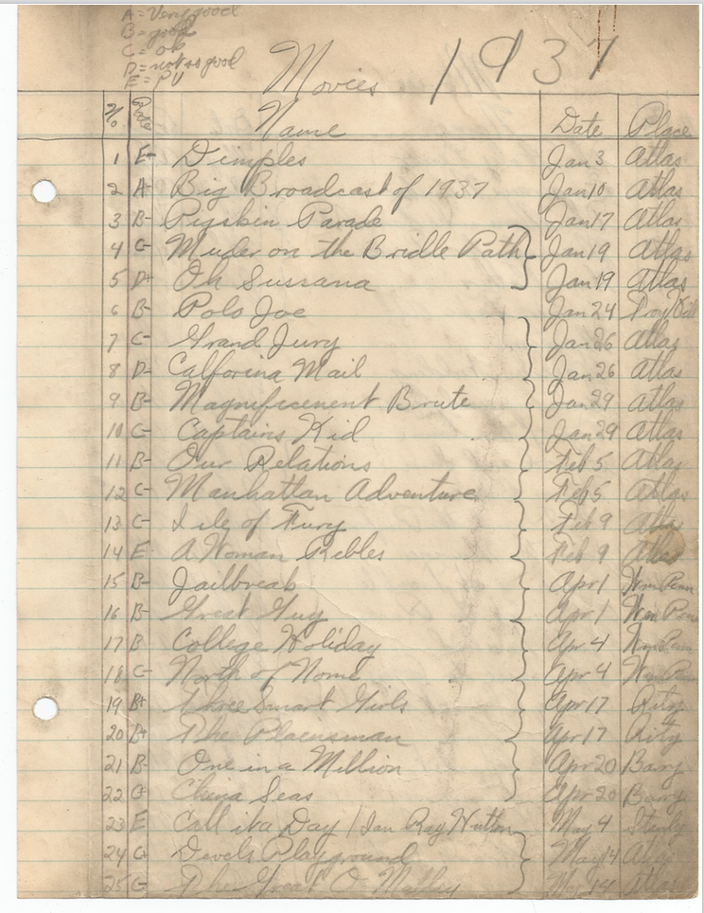
Dad’s Movie Log Page#1 (Note the Rating System at the top)
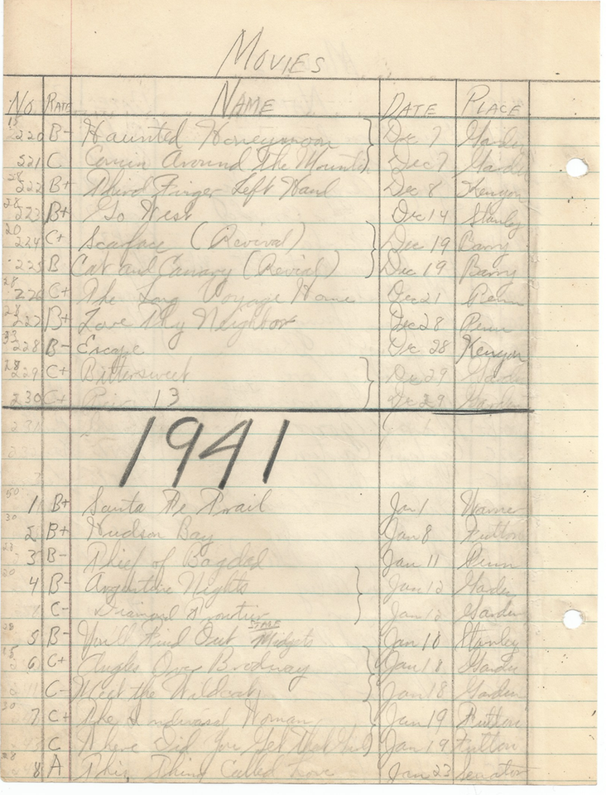
Dad’s Movie Log Page #24 (Note: 230 movies viewed in 1940)
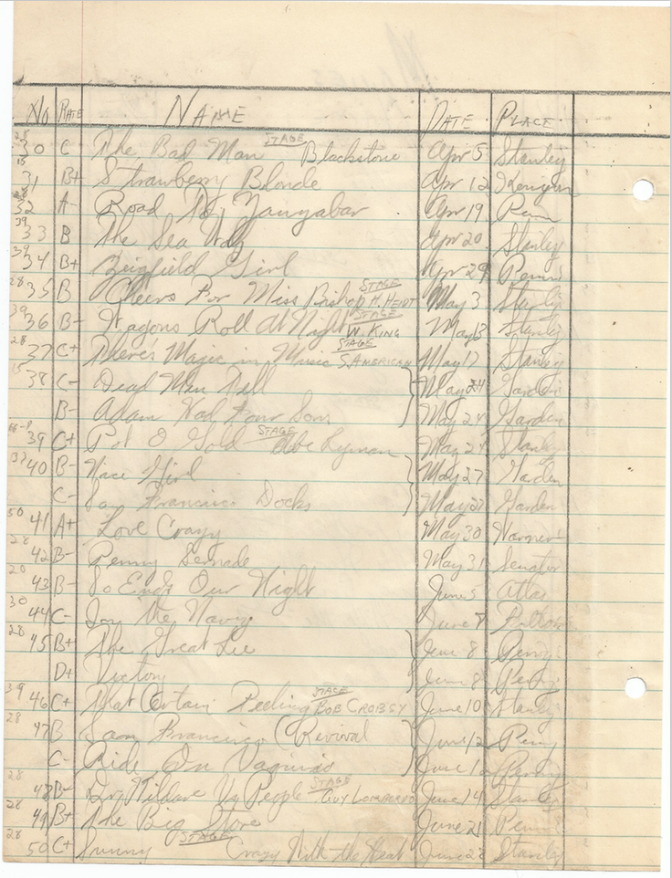
Dad’s Movie Log Page #26 (NOTE: Blackstone on Stage)
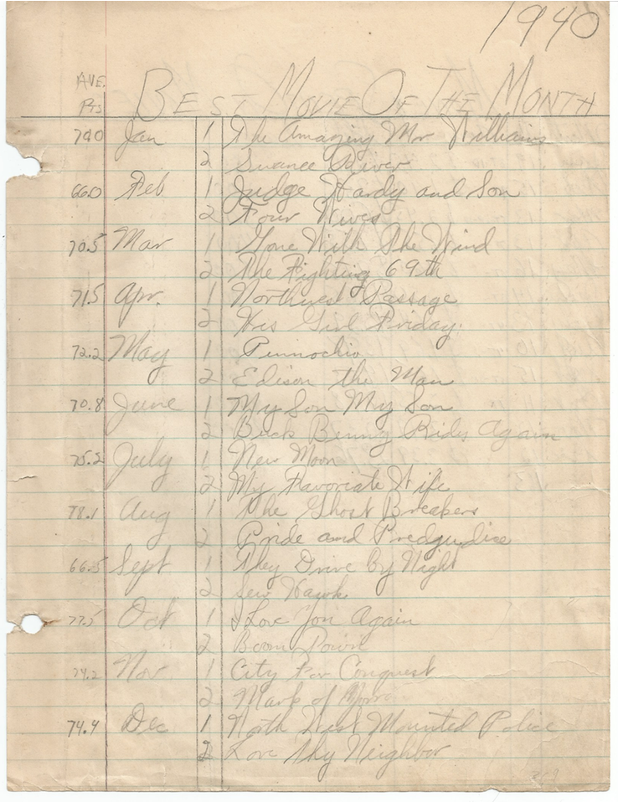
Dad’s Movie Log Page #41 (NOTE: % ranking system per month)
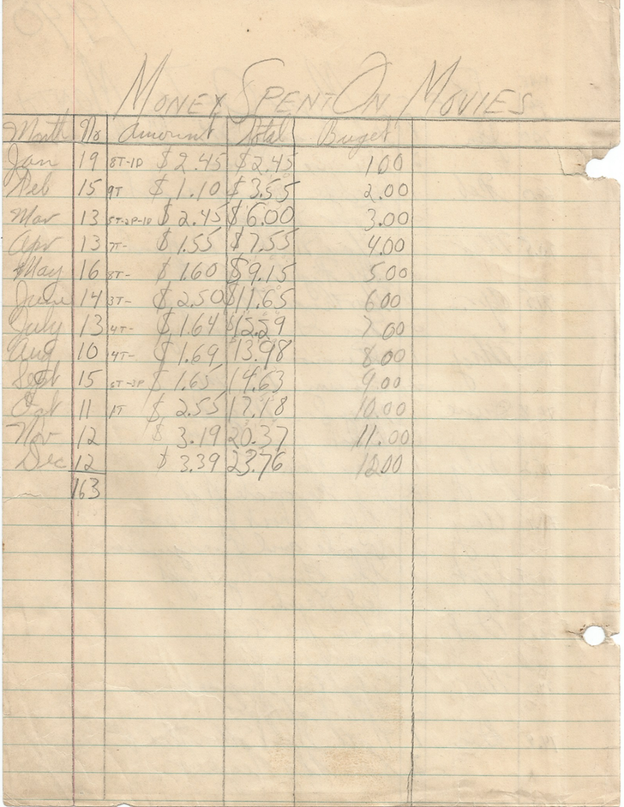
Dad’s Movie Log Page #43 (NOTE: This is just for 1 year 1940)

